عنوان المقالة. خط أندلسي، قياس17، نظامي، ثخين، 0 فارزة قبلية، 12 فارزة بعدية
(Ar. Title Andalus, Size 17, Normal, Bold, Forward 0pt, Backward 12pt)
En. Titre Calibri, Size 13, Italic, Bold, Forward 0pt, Backward 12pt
Fr. Titre Calibri, Taille 13, Italique, Gras, avant 0pt, après 12pt
First Name Last Name^{1}, First Name Last Name² Calibri, 10, Normal, Bold, Forward 0pt, Backward 12pt
1 Affiliation Calibri, 6.5, Italic, Forward 0pt, Backward 3pt
2 Affiliation Calibri, 6.5, Italic, Forward 0pt, Backward 3pt

الملخص: تحرير الملخصن و العنوان باللغتين العربية و الانجليزية ضروري بالنسبة لجميع المقالات. أندلسي، قياس 10، نظامي، 3فارزة قبلية، 3 فارزة بعدية
الكلمات المفتاحية: الكلمة الأولى، الكلمة الثانية،،.، 6 أو 7 كلمات مفتاحية كحد أقصى. أندلسي، قياس 8، نظامي، 0 فارزة قبلية، 0 فارزة بعدية

Abstract: The English and the Arabic abstracts and titles are obligatory for all papers. Calibri, 8, Normal, Forward 3pt, Backward 3 pt
Keywords: Keyword1, Keyword2, .., 6 or 7 Keywords. Calibri, 7, Normal, Forward 0pt, Backward 12pt

Résumé : Le résumé en français est facultatif pour les articles rédigés en anglais ou en langue arabe, Calibri 8, Normale, Avant 0pt, Après 3pt
Mots clés : Mot clé1, Mot clé2. Calibri, Taille 7, Italique, Avant 0pt, Après 12pt
1. Introduction Calibri, 11, Bold, Forward 0pt, Backward 6pt
The manuscript should not exceed ten (10) pages. Calibri, 9, Normal, Forward 0pt, Backward 6pt.
  - Section headings 2 Calibri, 10, Bold, Forward 0pt, Backward 6pt
A selection of best papers, after review will be published free of costs in a Regular/ Special Issue in the Journals: MMEP (ISSN 2369-0739) and JAEST (ISSN 2352-9873).
1.1.1. Section headings 3 Calibri, 9, Bold, Forward 0pt, Backward 6pt
Calibri, 9, Normal, Forward 0pt, Backward 6pt. (1)
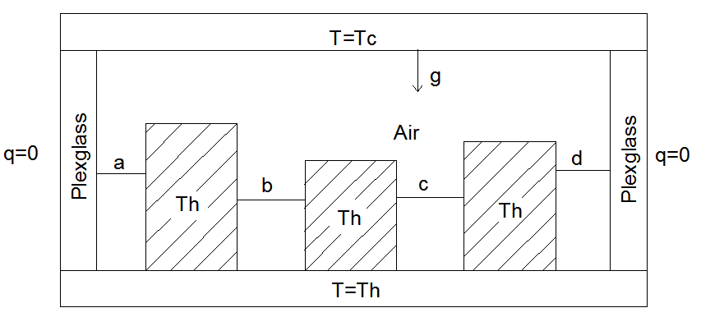
Fig. 1. Figure Caption. Calibri, 9, Normal, Forward 6pt, Backward 12pt
Table 1. Table. Calibri, 8, Normal, Forward 18pt, Backward 3pt
Exemple | 1
Calibri , 8, Normal, Forward 2pt, Backward 2pt | 2
2. Conclusion Calibri, 11, Bold, Forward 0pt, Backward 6pt
Cite references in the text by name and year in parentheses, as in the following examples: radiation is expressed by the Hottel-Whillier-Bliss equation (Duffie and Beckman 2013). This observation was confirmed by Ouamane and Lempérière (2006). This mechanism has been widely studied (Soltani et al. 2003; Zahi et al. 2003; Betka and Moussi 2004).

References
Betka, A., A. Moussi (2004) Performance optimization of a photovoltaic induction motor pumping system, Renewable Energy 29(14): 2167-2181.
Duffie, J.A., W.A. Beckman (2013) Solar Engineering of Thermal Processes: Fourth Edition, New York, Wiley.
El Hadrami, I., A. El Hadrami (2009) Breeding date palm, in Breeding Plantation Tree Crops: Tropical Species. Ed. S.M. Jain and P.M. Priyadarshan, New York, Springer, pp. 191-216.
Ouamane, A., F. Lempérière (2006) Design of a new economic shape of weir. Proceedings of the International Symposium on Dams in the Societies of the 21st Century, Barcelona, Spain, pp. 463-470.

